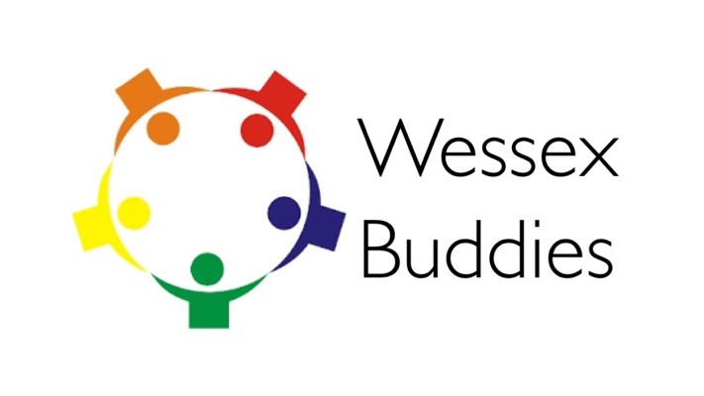
Senior Buddy Application Form
Please fill out the form below to allow us to help match you to a buddy:
Name
Preferred email address
Where do you live?
What level of training are you?
Are you a full or less than full time trainee?
Where is your training post from March 2017?
What are your career aspirations (including SPIN or Grid)?
Have you had any previous mentoring experience or training?
What other work related interests do you have? e.g. education, research
What non-work related interests do you have? i.e. hobbies?
Tell us about yourself and what you can offer to a junior buddy:
(approx. 250 words)

